**SALEM COLLEGE OF ENGINEERING AND TECHNOLOGY**

**DEPARTMENT OF COMPUTER SCIENCE AND ENGINEERING**

**IBM NALAIYA THIRAN**

**ASSIGNMENT-2**

BULID A PYTHON CODE ,ASSUME U GET TEMPERATURE AND HUMIDITY VALUES AND WRITE A CONDITION TO CONTINOUSLY DETECT ALARM IN CASE OF HIGH TEMPERATURE

**PROGRAM:**

#from machine import Pin

import random

from time import sleep

#btn=Pin(4,Pin.IN)

while True:

temp = random.randint(1,100)

print("current temp=",temp)

humid = random.randint(1,100)

print("current humid=",humid)

if(temp>=50 and humid<35):

print("Alarm On")

else:

print("Alarm Off")

sleep(2)

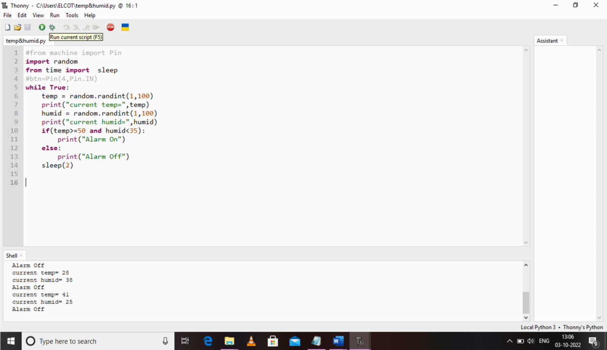OUTPUT: